Use of ORP for Wastewater Process Control

What is ORP?
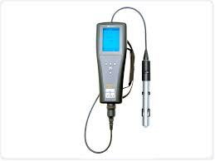
ORP (Oxidation Reduction Potential) is an indication of a solution’s ability to oxidize or reduce another substance. Everything that is in water has a potential or ability, ORP is the sum of these potentials. ORP is measured in millivolts (mV).ORP will determine if the potential is positive (oxidative) or negative (reductive). Very simply put, negative ORP values can be thought of as negative dissolved oxygen. The more negative the ORP, the more septic. As a substance becomes more oxidized, the ORP will increase. Different reactions in wastewater will occur at different ORP values.

Wastewater Reactions and Associated ORP values
Biochemical Reaction | ORP mV
Nitrification | +100 to +300
Aerobic BOD reduction | +50 to +250
Denitrification | +50 to -50
Sulfide Formation | -50 to -250
Orthophosphate release | -100 to -250
Organic Acid Formation | -100 to -225
Methane production | -175 to -400

Impact of ORP on Biological Nutrient Removal
- Nitrification
  - Nitrification is a two-step process that converts ammonium to and end products of nitrite, and finally nitrate removing ammonia to a higher degree than bacteria would naturally take up as a nutrient (assimilate).
    - A critical factor for nitrification is a high level of oxidation and dissolved oxygen concentrations of at least 1-3 mg/L
      - Nitrification occurs at ORP values of +100 to +300

- Aerobic BOD removal
  - Aerobic treatment involves the conversion of organic matter (food/ BOD) to end products of carbon dioxide, new bacteria, and water
    - For these reactions to occur, there needs to be an aerobic environment as free oxygen is the final electron receptor.
      - Aerobic BOD removal occurs at +50 to +250 mV
- Denitrification
  - Denitrification is the removal of nitrate and conversion to nitrogen gas and new bacteria
  - Bacteria will use free oxygen first, then the oxygen molecules in nitrate, and sulfate (in this order). For this reason free dissolved oxygen must not be present for this reaction
    - The bacteria take up a carbon source (BOD) and use the oxygen in nitrate for this reaction
      - Denitrification occurs between +50 and -50 mV
        - Note that the inside of the flocs may be anoxic at low positive ORP values
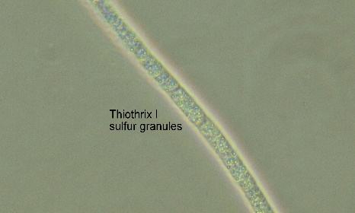
- Sulfide Formation
Thiothrix I with Sulfur Granules
  - Once all free oxygen and nitrate is gone, bacteria will use the oxygen in sulfate and reduce this to sulfide
  - Hydrogen sulfide is a dangerous gas that may exhibit a “rotten egg” odor.
  - Certain filamentous bacteria that can cause sludge bulking and settling problems are able to utilize hydrogen sulfide for energy
    - Thiothrix I and II
    - Beggiatoa spp
    - Type 021N
    - Type 0914
      - At a pH <7, 1 mg/L of hydrogen sulfide or more can be toxic to floc forming bacteria and at a pH of 8, over 100 mg/L is toxic (Reference: Rick Marshall, Dr. Michael Richard)
        - Sulfide formation occurs at ORP values of -50 to -250 mV
- Orthophosphate release
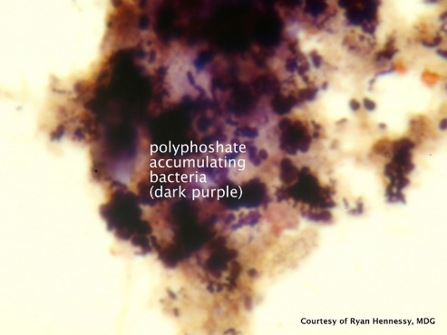
  - Enhanced Biological Phosphorus Removal is a process in which certain bacteria are selected that remove a higher percentage of phosphorus than bacteria that occur naturally in wastewater treatment. There is an anaerobic zone, and an aerobic zone needed for this process.
Polyphosphate Accumulating Organisms
    - To optimize this process, the ORP needs to be low enough in the anaerobic zone, that polyphosphate accumulating organisms (PAOs) release stored orthophosphate and uptake soluble BOD (volatile fatty acids).
      - When these bacteria then enter the aerobic zone, they have a competitive advantage as they have stored food to oxidize. They then replenish their stored polyphosphate (luxury uptake) and ultimately end up having a higher phosphorus content in their cellular material than other bacteria in wastewater treatment
        - A carbon source (soluble BOD) is needed to drive the ORP down to the -100 to -250 where orthophosphate release occurs
          - Note that any time the ORP enters these values, orthophosphate can be released
            - This includes areas such as the final clarifier
- Organic Acid Formation
  - Organic acid formation is needed in enhanced biological nutrient removal processes
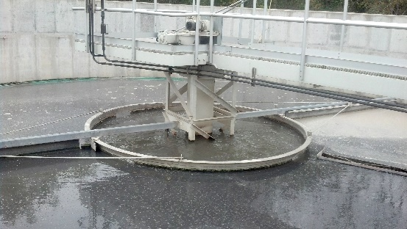
    - In areas where there is organic matter (BOD) and the ORP value is approximately -100 to -225 mV, anaerobic bacteria convert the organic matter to organic acids, which are soluble, and readily available to be absorbed through the cell membrane of the bacteria
Primary Fermenter generating VFAs
      - Organic Acids or volatile fatty acids are the food source for denitrifying bacteria and polyphosphate accumulating organisms
          - Volatile Acids have between 1 and 5 carbon atoms. These acids are acetic, butyric, proprionic, caproic, and valeric
        - Organic acids are also a food source for zooglea and many other organisms such as filamentous bacteria, which we do not want to proliferate in wastewater treatment. Literature from Dr. Michael Richard and Dr. David Jenkins cites >100 mg/L of organic acids to be a cause for filamentous bulking
          - For these reasons, it is important that most of them are removed in the anaerobic selector

- Methane Formation
  - Methane formation is an end product of anaerobic treatment. In anaerobic treatment, Hydrogen and Acetic acid are produced by acid forming bacteria, and this is food for the methane formers.
    - Methane formation occurs at ORP values of -175 to -400 mV
      - Methanogens are highly sensitive to changes in pH, temperature, and other stresses

