Frequently Asked Questions: BOD, COD, and TOC

Soluble vs Total
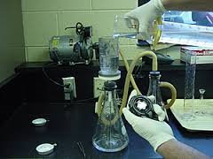
For both COD, BOD, and TOC, a version of this test can be ran that involves filtering the sample prior to testing. This distinguishes particulate vs readily available food. Soluble BOD or COD will always be a fraction of the total unfiltered test.

What does BOD, COD, and TOC stand for?
- BOD (Biochemical Oxygen Demand): The rate at which organisms use oxygen in the sample while stabilizing organic matter. This measures the strength of the water based on the amount of oxygen the bacteria consume, typically the test is ran for 5 days (BOD5) and incubated at 20 degrees C. The higher the BOD, the stronger the waste.
Vacuum filter for removing particulates
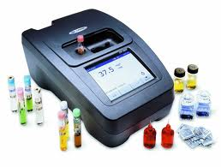
Spectrophotometer
- COD (Chemical Oxygen Demand): The measure of oxygen consuming capacity consumed by a chemical oxidant. This test takes a few hours to run. The results of COD test are not necessarily related to BOD, because the chemical oxidant may react with other substances that the bacteria are not able to oxidize.

- TOC (Total Organic Carbon): This is a test that measures the total amount of organic carbon in water. There are continuously monitoring instruments for this, as well as testing procedures that can be ran in the lab for several hours for results using a spectrophotometer similarly as in the COD test.

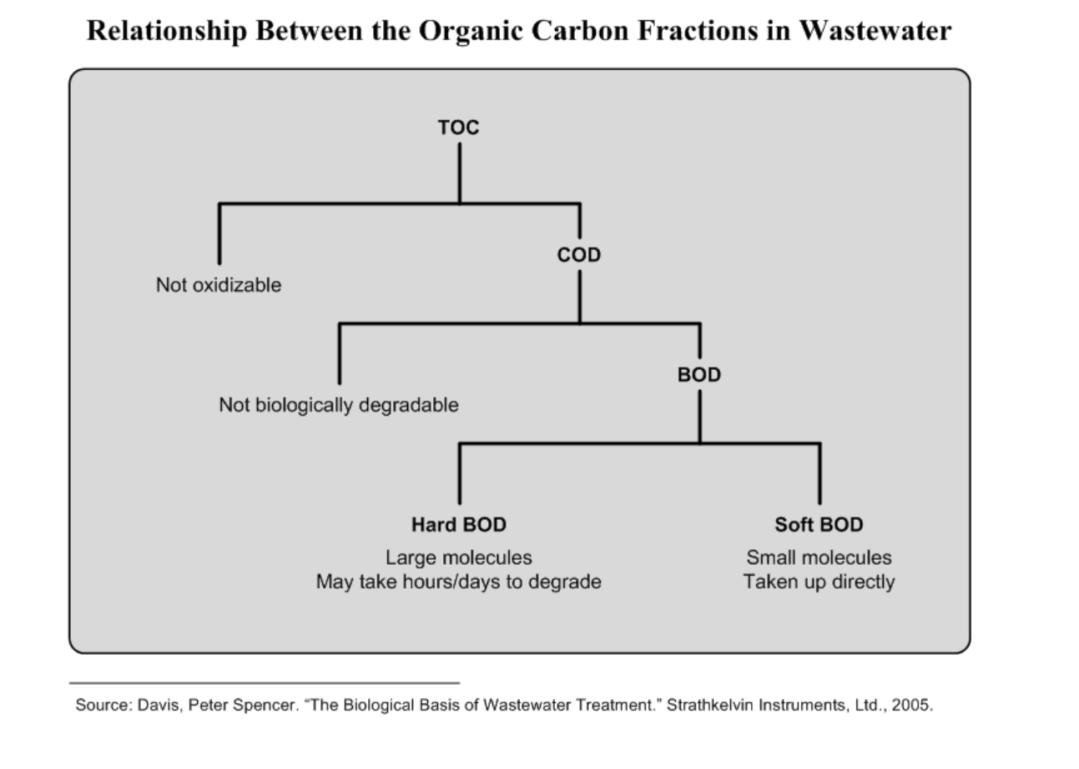

Frequently Asked Questions
- Does COD take into consideration the oxygen demand for nitrification?
  - No
- Does TOC take into consideration the oxygen demand for ammonia?
  - No, ammonia is inorganic
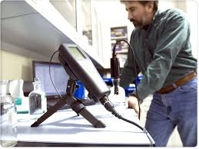
- Is BOD always less than COD?
BOD measurement YSI probe
  - Yes, BOD is always less than COD because the oxidant used in the test may react with substances that the bacteria in the BOD test do not react with
- Is BOD always less that TOC?
  - Yes, Because the oxidant used in the TOC test may react with substances that the bacteria in the BOD test do not react with
- What is a typical BOD: COD ratio?
  - In many instances, a fairly reliable trend of COD: BOD can be established through many tests. A COD: BOD ratio should never be assumed. In municipal plants it is very common to have a COD: BOD ratio of 2:1, but this should be confirmed through a series of tests and ongoing periodic split samples. In some industrial wastewaters, a reliable COD: BOD ratio cannot be established due to production changes in the industry.
- Can I find a typical BOD: TOC ratio?
  - The same rules for establishing a BOD:COD ratio apply here
- What does CBOD mean?
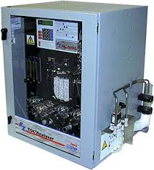
  - CBOD stands for Carbonaceous Biochemical Oxygen Demand. In this test, nitrifying bacteria (that consume ammonia) are inhibited. This test is commonly ran if there is thought to be a high amount of ammonia present in the sample
TOC analyzer
- Should I use COD or TOC for process control at my plant?
  - If COD or TOC are reliable indicators of BOD, then these can become very valuable tools for process control. An advantage of using these is that results can be obtained within several hours. In some instances, the flow can be controlled to the treatment plant in industrial wastewaters from an equalization tank to maintain a fairly constant amount of food to microorganisms (F/M ratio).
- Can I change my effluent permit to something other than BOD?
  - This, depends on the flexibility of the governing agency. In some cases, if strong BOD: TOC ratio can be established, permits have been changed to TOC.
  - In some instances, where there is a high amount of ammonia present, variances can be granted to inhibit any nitrogenous oxygen demand and permits can be changed to CBOD. Again, this is the decision of the regulatory agency.
- Can I use BOD as a measurement of toxicity?
  - If toxicity is present in the sample, BOD values will decrease with increasing concentrations of sample volume in the test. If there is high suspended solids and low BOD, this may also be an indication that toxicity or inhibition is occurring during the incubation period, preventing the bacteria from consuming oxygen.

*Next page has chart courtesy of Hach stating advantages and disadvantages of each test
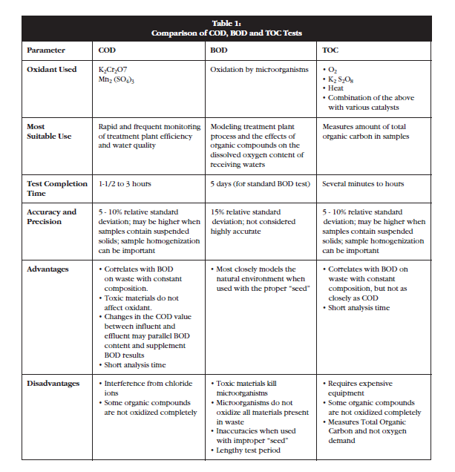

Reference
- http://www.hach.com/
- http://www.ysi.com/index.php
- Davis, Peter Spencer “The Biological Basis of Wastewater Treatment; 2005

